Slate Stories
by Justin Time
D 2018, filmed in Wales, UK, 44 min

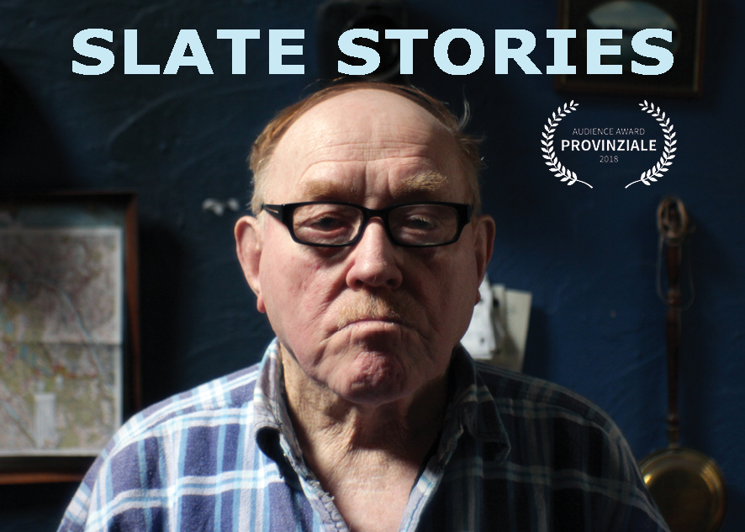

SYNOPSIS (SHORT)
For generations, slate mining was deeply interwoven with peoples‘ lives in the North Welsh villages. Now, the community is changing after the decline of the industry. Former miners and family members share their stories and one of them also his VHS footage from underground.

SYNOPSIS (LONG)
A stonemason himself, filmmaker Justin Time went to explore the former slate region of Corris and Aberllefenni to talk to miners, workers and their families. For generations, slate mining was deeply interwoven with peoples‘ lives in the North Welsh villages. With the decline of the mining industry, the structure of the region is changing drastically. Underground footage shot by former miner Glyn Davies shows a world that no longer exists. Work in the mines was hard, but it gave the region a purpose and an identity. Today, what´s left is tourism. With reluctance, the original Welsh population observes the influx of English people seeking weekend cottages.

TEAM
Director, producer, DOP, editor:
Justin Time
Additional camera VHS footage:
Glyn Davies, former quarryman at Aberllefenni Slate Quarries
Sound Editor:
Brooke Trezise
Colour Correction:
Maike Zimmermann
With:
Christal Davies
Darren Davies
Glyn Davies
Drew Page
Glyn Roberts
Ant Taylor

BIOGRAPHY JUSTIN TIME
Justin Time is a stonemason turned visual artist turned filmmaker. His films examine space and social dynamics. As a stonemason, Justin Time went on a traditional working journey around Europe for three years. He received an MFA at Art School Berlin Weißensee and studied Urban Studies at San Francisco Art Institute and at filmArche Berlin. He was artist in residence at Villa Aurora, Los Angeles, in 2013 and received several grants and awards for his films.

Director´s Statement
Originally a stonemason by trade, I immediately connected to the intense relationship to the material held by the slate mining community in the Welsh villages. 'Talking stone' was speaking the same language, in a way. On the other hand, coming from outside the community and being neither Welsh nor English enhanced my ability to ask questions about this charged intercultural relationship. As a gender-queer person, I have a focus on the places in between, and try to put into question ideas of normality. My work almost always has a layer of confronting power dynamics. My goal is to evoke a space for thought, and discussion, and to broaden the perception to often overseen things and realities.

Filmography
2018 Slate Stories, 44 min
2017 Chasing Houses, 60 min
2016 „...dass das heute noch immer so ist“ / „continuities of
exclusion"; with Tom Weller and Heike Rode, 52 min
2014 Gay Abandon (camera), 5 min
2012 Night in the Woods (script, camera), 12 min
2012 Labels, Video/Installation, 15 min
2011 I am a work of art; with Martina Mina, Video, 8 min
2010 Monster, Video, 2 min
2008 Möhrenstraße, 14 min/ loop
2007 Toss it, Baby, Video, 7 min/ loop
2007 Alter Egos, Video animation, 4 min
2006 Haunted House Ride, Video, 1 min
2005 Passing Suburbia; with Christine Woditschka, Video, 8 min/loop

ScreeningS
+++ Audience Award: Best Short Documentary
7.10.2018 Provinziale, Filmfest Eberswalde
https://filmfest-eberswalde.de

Contact
Justin Time
Mariannenstr. 7a
D 10997 Berlin
Tel.: +49 176 967 54 593
Email: jbrathke@gmx.de
http://justintimeproductions.de/en/

