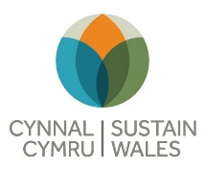
Film Hub Wales
Reducing Emissions - Type your own analysis into the boxes during the session on the 29th

Issue | Action | Target
Electricity supply

Heating – water and space

Audience transport

Catering and food supplies

Single use plastics

Other consumables e.g. paper

Other procurement e.g. equipment

Waste management

Programming

Innovation and Business Models

Anything else?

